Toward Super High-Level SDN Programming

Introduction
Software-Defined Networking offers the appeal of a simple, centralized programming model for managing complex networks. However, challenges in managing low-level details, such as setting up and maintaining correct and efficient forwarding tables on distributed switches, often compromise this conceptual simplicity. We design the SuperSDN programming framework that substantially simplifies the SDN control plane programming, and demonstrate its powerfulness and efficiency in data intensive science networks. Figure 1 provides an overview of the SuperSDN framework.

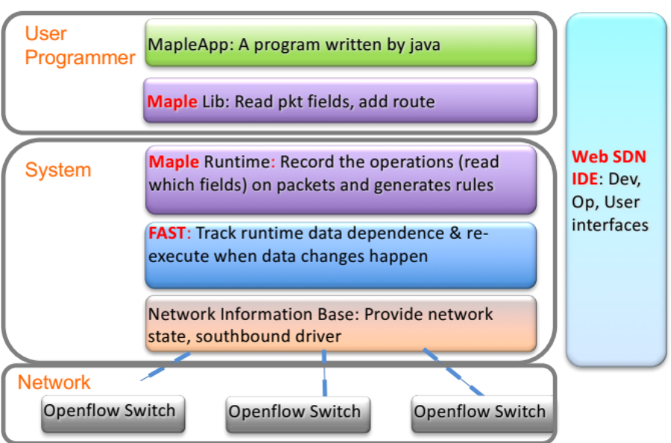
Figure 1. An overview of the SuperSDN framework.

The SuperSDN programming framework is composed of three key components. First, we develop a web-based integrated development environment (IDE) for users to develop, debug and evaluate control plane applications. The SuperSDN IDE provides three views, i.e., the user view, the developer view and the operator view, of the underlying networks. In the SuperSDN IDE, users can create a control plane project with a few simple steps, develop the application using high-level programming language, i.e., Java, and test and deploy the applications on both simulated environments, e.g., Mininet, and physical networks.

To support the high-level programming model in the IDE, in which the programmer defines network-wide forwarding behaviors with the application of a high-level algorithm, we design the Maple runtime system in the SuperSDN framework. Maple provides an abstraction that the programmer-defined, centralized policy runs conceptually on every packet entering a network, and hence is oblivious to the challenge of translating a high-level policy into sets of rules on distributed individual switches. The core of Maple is an optimizer that discovers reusable forwarding decisions from a generic running control program. Specifically, the optimizer develops a data structure called a trace tree that records the invocation of the programmer-supplied f on a specific packet, and then generalizes the dependencies and outcome to other packets. field. A trace tree captures the reusability of previous computations and hence substantially reduces the number of invocations of f and, in turn, the computational demand.

Though Maple greatly simplifies programmers’ work in developing control plane applications, it shares a common characteristic with other control-plane programming models, i.e., their computation all depends on network states. As a result, programmers have to manually track network state change, clean up the side effects when state change happens. To eliminate such complexity, we develop a novel, high-level programming abstraction called the Function Automation SysTem (FAST). Implemented as a shim layer on top of the native OpenDaylight MD-SAL datastore API, FAST provides simple APIs for users to create, compose and manage control applications as function instances. FAST automatically tracks the state-dependency during the execution of every function instance and registers data change listeners based on the dependency tracking. When network state changes, FAST automatically identifies the affected function instances, rollbacks the execution of these instances and re-executes affected instances to restore the network to the correct up-to-date state. Figure 2 provides a comparison between current SDN programming paradigm and the SuperSDN programming framework.

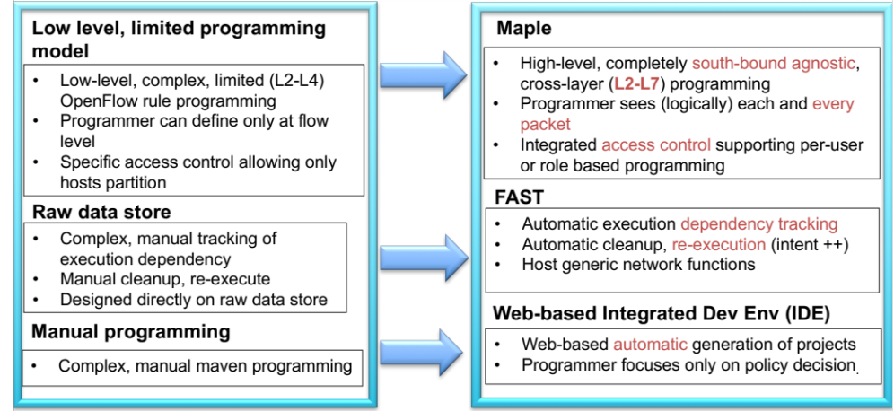
Figure 2. Comparison between current SDN programming paradigm
and the SuperSDN framework.

Demonstration
In SC16, we demonstrate the powerfulness and efficiency of SuperSDN by developing a Science DMZ application. The demo application analyzes the metadata of different traffic flows, and automatically forwards the large-volume scientific flows and the low-volume non-scientific flows along different paths in the network. Developing such an application typically requires hundreds of lines of low-level, complex code in state-of-the-art SDN controllers, such as OpenDaylight and ONOS. However, in the SuperSDN framework, we demonstrate that this application can be implemented using with only tens of lines of high-level, south-bound agnostic code.

Future work
We plan to deliver the product version of the SuperSDN programming framework in the next 12 months. Prior to the official release, we are working on (1) integrating more advanced features, including machine-learning-based fast reroute, network policy conflict resolution, etc., into SuperSDN, (2) evaluating the performance of the SuperSDN programming framework via on various SDN testbeds, including the NCL testbed at National University of Singapore, the GTS testbted at the GEANT association in Europe, and the 100Gb SDN testbed in Caltech.

